目录

1.项目结构 2

2.Restful 12

2.1.区别 12

2.2.JsonPath说明 14

2.3.JsonView使用 14

2.3.1使用接口来声明多个视图 14

2.3.2在值对象的get方法上指定视图 14

2.3.3在controller方法上指定视图 14

2.4.@Valid 参数校验, 15

2.4.1校验 15

2.4.2.自定义校验 16

2.5.Restful Api拦截 18

2.5.1过滤器 18

2.5.2.使用拦截器 19

2.5.3.使用切面 22

2.6.上传下载 23

2.7.异步处理Rest服务 25

2.7.1使用Runnable异步处理 25

2.7.2使用DeferredResult异步处理 25

2.8使用swagger生产文档 28

2.9.wiremock 29

3. Spring Security认证 30

3.1说明 30

3.2.自定义用户逻辑认证 32

3.2.1处理用户信息获取逻辑 32

3.2.2.个性化用户认证流程 33

3.3图片验证码 41

3.3.1实现图片验证码 41

3.3.2.验证码校验 43

3.3.3.图形验证码重构 45

# 1.项目结构

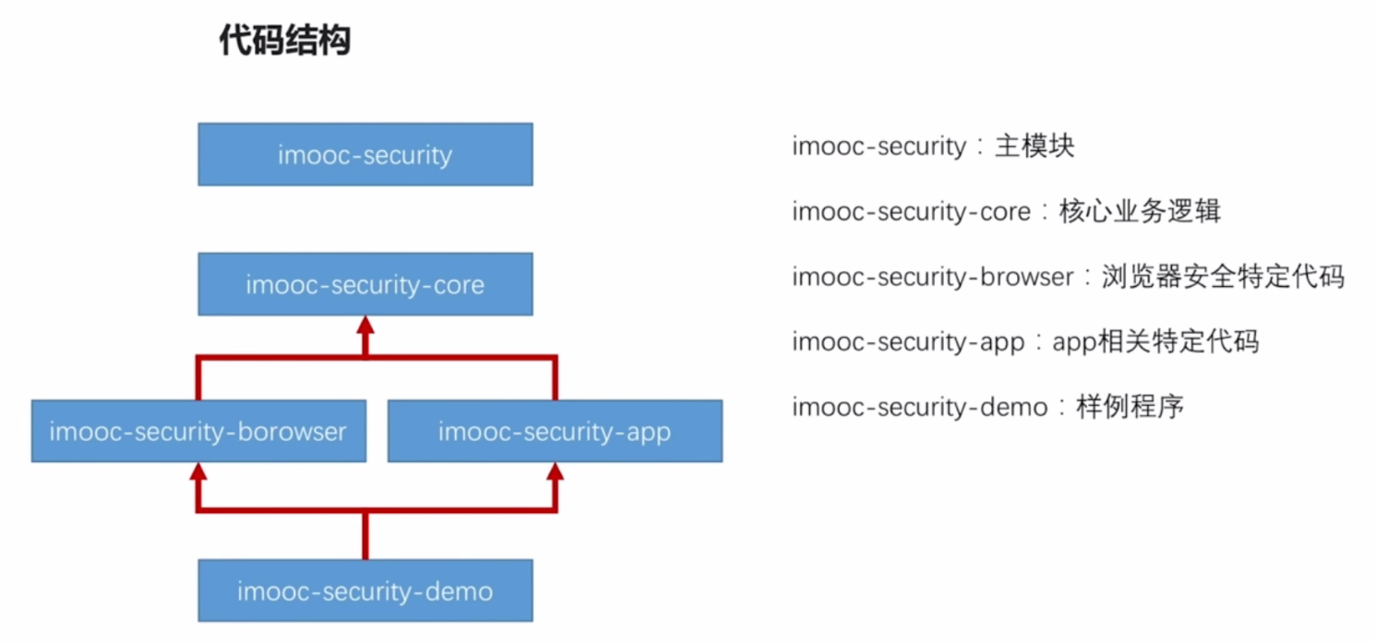

com.swb.security

imooc-security:没有任何java代码,作用：统一下面的四个模块，对四个子模块统一执行maven命令,打包等

imooc-security-core:登录实现逻辑是在这里实现的

imooc-security-browser, imooc-security-app：封装浏览器和app 安全相关的代码，是安全模块提供给其他模块项目使用。

imooc-security-demo是演示其他项目如何使用演示。

1. 创建一个空项目security

maven分别创建5个模块

imooc-security 导入io.spring.platform，spring-cloud-dependencies

|  |
| --- |
| <project xmlns="http://maven.apache.org/POM/4.0.0"  xmlns:xsi="http://www.w3.org/2001/XMLSchema-instance"  xsi:schemaLocation="http://maven.apache.org/POM/4.0.0 http://maven.apache.org/xsd/maven-4.0.0.xsd">  <modelVersion>4.0.0</modelVersion>  <groupId>com.swb.security</groupId>  <artifactId>imooc-security</artifactId>  <version>1.0.0</version>  <packaging>pom</packaging>  <properties>  <imooc.security.version>1.0.0</imooc.security.version>  </properties>  <dependencyManagement>  <dependencies>  <dependency>  <groupId>io.spring.platform</groupId>  <artifactId>platform-bom</artifactId>  <version>Cairo-SR7</version>  <type>pom</type>  <scope>import</scope>  </dependency>  <dependency>  <groupId>org.springframework.cloud</groupId>  <artifactId>spring-cloud-dependencies</artifactId>  <version>Greenwich.SR5</version>  <type>pom</type>  <scope>import</scope>  </dependency>  </dependencies>  </dependencyManagement>  <build>  <plugins>  <plugin>  <groupId>org.apache.maven.plugins</groupId>  <artifactId>maven-compiler-plugin</artifactId>  <version>2.3.2</version>  <configuration>  <source>1.8</source>  <target>1.8</target>  <encoding>UTF-8</encoding>  </configuration>  </plugin>  </plugins>  </build>  <modules>  <module>../imooc-security-app</module>  <module>../imooc-security-browser</module>  <module>../imooc-security-core</module>  <module>../imooc-security-demo</module>  </modules>  </project> |

imooc-security-core

|  |
| --- |
| <project xmlns="http://maven.apache.org/POM/4.0.0"  xmlns:xsi="http://www.w3.org/2001/XMLSchema-instance"  xsi:schemaLocation="http://maven.apache.org/POM/4.0.0 http://maven.apache.org/xsd/maven-4.0.0.xsd">  <modelVersion>4.0.0</modelVersion>  <artifactId>imooc-security-core</artifactId>  <parent>  <groupId>com.swb.security</groupId>  <artifactId>imooc-security</artifactId>  <version>1.0.0</version>  <relativePath>../imooc-security</relativePath>  </parent>  <dependencies>  <dependency>  <groupId>org.springframework.cloud</groupId>  <artifactId>spring-cloud-starter-oauth2</artifactId>  </dependency>  <dependency>  <groupId>org.springframework.boot</groupId>  <artifactId>spring-boot-starter-data-redis</artifactId>  </dependency>  <dependency>  <groupId>org.springframework.boot</groupId>  <artifactId>spring-boot-starter-jdbc</artifactId>  </dependency>  <dependency>  <groupId>mysql</groupId>  <artifactId>mysql-connector-java</artifactId>  <version>8.0.15</version>  </dependency>  <dependency>  <groupId>org.springframework.social</groupId>  <artifactId>spring-social-config</artifactId>  </dependency>  <dependency>  <groupId>org.springframework.social</groupId>  <artifactId>spring-social-core</artifactId>  </dependency>  <dependency>  <groupId>org.springframework.social</groupId>  <artifactId>spring-social-security</artifactId>  </dependency>  <dependency>  <groupId>org.springframework.social</groupId>  <artifactId>spring-social-web</artifactId>  </dependency>  <dependency>  <groupId>commons-lang</groupId>  <artifactId>commons-lang</artifactId>  </dependency>  <dependency>  <groupId>commons-collections</groupId>  <artifactId>commons-collections</artifactId>  </dependency>  <dependency>  <groupId>commons-beanutils</groupId>  <artifactId>commons-beanutils</artifactId>  </dependency>  </dependencies>  </project> |

imooc-security-browser,

|  |
| --- |
| <?xml version="1.0" encoding="UTF-8"?>  <project xmlns="http://maven.apache.org/POM/4.0.0"  xmlns:xsi="http://www.w3.org/2001/XMLSchema-instance"  xsi:schemaLocation="http://maven.apache.org/POM/4.0.0 http://maven.apache.org/xsd/maven-4.0.0.xsd">  <modelVersion>4.0.0</modelVersion>  <artifactId>imooc-security-browser</artifactId>  <parent>  <groupId>com.swb.security</groupId>  <artifactId>imooc-security</artifactId>  <version>1.0.0</version>  <relativePath>../imooc-security</relativePath>  </parent>  <dependencies>  <dependency>  <groupId>com.swb.security</groupId>  <artifactId>imooc-security-core</artifactId>  <version>${imooc.security.version}</version>  </dependency>  <dependency>  <groupId>org.springframework.session</groupId>  <artifactId>spring-session</artifactId>  </dependency>  </dependencies>  </project> |

imooc-security-app

|  |
| --- |
| <?xml version="1.0" encoding="UTF-8"?>  <project xmlns="http://maven.apache.org/POM/4.0.0"  xmlns:xsi="http://www.w3.org/2001/XMLSchema-instance"  xsi:schemaLocation="http://maven.apache.org/POM/4.0.0 http://maven.apache.org/xsd/maven-4.0.0.xsd">  <modelVersion>4.0.0</modelVersion>  <artifactId>imooc-security-app</artifactId>  <parent>  <groupId>com.swb.security</groupId>  <artifactId>imooc-security</artifactId>  <version>1.0.0</version>  <relativePath>../imooc-security</relativePath>  </parent>  <dependencies>  <dependency>  <groupId>com.swb.security</groupId>  <artifactId>imooc-security-core</artifactId>  <version>${imooc.security.version}</version>  </dependency>  </dependencies>  </project> |

imooc-security-demo

|  |
| --- |
| <?xml version="1.0" encoding="UTF-8"?>  <project xmlns="http://maven.apache.org/POM/4.0.0"  xmlns:xsi="http://www.w3.org/2001/XMLSchema-instance"  xsi:schemaLocation="http://maven.apache.org/POM/4.0.0 http://maven.apache.org/xsd/maven-4.0.0.xsd">  <modelVersion>4.0.0</modelVersion>  <artifactId>imooc-security-demo</artifactId>  <parent>  <groupId>com.swb.security</groupId>  <artifactId>imooc-security</artifactId>  <version>1.0.0</version>  <relativePath>../imooc-security</relativePath>  </parent>  <dependencies>  <dependency>  <groupId>com.swb.security</groupId>  <artifactId>imooc-security-browser</artifactId>  <version>${imooc.security.version}</version>  </dependency>  </dependencies>  </project> |

以上为项目的主要结构，maven管理项目，视频是使用STL与IDEA有差异

1. Gradle创建项目

项目实际使用gradle管理

建立一个Spring Boot项目SecurityGradle

本地路径: D:\MY\IDEA\securityGradle

Github地址:

Gradle版本为4.10.2 ，使用当时最新的6.2.2构建失败故用原先电脑的版本

group = 'com.swb.security' name='security-gradle' version='1.0.0'

空项目，什么都没有

创建四个子模块

右键项目,选择新建模块，选择gradle项目,创建security-core,app,browser,demo

修改父模块的build.gradle文件，加入

|  |
| --- |
| group 'com.swb.security'  version '1.0.0'  allprojects {  gradle.projectsEvaluated {  tasks.withType(JavaCompile) {  options.compilerArgs << "-Xlint:unchecked" << "-Xlint:deprecation"  }  }  }  buildscript {  repositories {  maven { url "http://maven.aliyun.com/nexus/content/groups/public" }  mavenCentral()  }  dependencies {  classpath 'org.springframework.boot:spring-boot-gradle-plugin:2.2.5.RELEASE'  }  }  subprojects {  apply plugin: 'java'  sourceCompatibility = 1.8  targetCompatibility = 1.8  [compileJava, compileTestJava]*.options*.encoding = 'UTF-8'  repositories {  mavenCentral()  }  dependencies {  }  } |

Core模块

|  |
| --- |
| buildscript {  repositories {  maven { url "http://maven.aliyun.com/nexus/content/groups/public" }  mavenCentral()  }  dependencies {  classpath 'org.springframework.boot:spring-boot-gradle-plugin:2.2.5.RELEASE'  }  }  apply plugin: 'java'  apply plugin: 'org.springframework.boot'  group 'com.swb.security'  version '1.0.0'  sourceCompatibility = 1.8  ext {  springBootVersion = "2.2.5.RELEASE"  cloudVersion = "2.2.1.RELEASE"  springBootMybatisVersion = "2.1.2"  mysqlConnector = "8.0.19"  springSocial = "1.1.6.RELEASE"  junitVersion = '4.13'  pagehelperVersion = '1.2.10'  mapperVersion = '2.1.5'  lombokVersion = '1.18.12'  compileJava.options.encoding = 'UTF-8'  compileTestJava.options.encoding = 'UTF-8'  }  dependencies {  compile "org.springframework.boot:spring-boot-starter:${springBootVersion}"  compile "org.springframework.boot:spring-boot-starter-data-redis:${springBootVersion}"  compile "org.springframework.boot:spring-boot-starter-web:${springBootVersion}"  compile "org.mybatis.spring.boot:mybatis-spring-boot-starter:${springBootMybatisVersion}"  compile "org.springframework.cloud:spring-cloud-starter-oauth2:${cloudVersion}"  compile "org.springframework.boot:spring-boot-starter-test:${springBootVersion}"  compile "mysql:mysql-connector-java:${mysqlConnector}"  compile "org.springframework.cloud:spring-cloud-starter:${cloudVersion}"  compile "org.springframework.social:spring-social-core:${springSocial}"  compile "org.springframework.social:spring-social-config:${springSocial}"  compile "org.springframework.social:spring-social-security:${springSocial}"  compile "org.springframework.social:spring-social-web:${springSocial}"  compile "com.github.pagehelper:pagehelper-spring-boot-starter:${pagehelperVersion}"  compile "tk.mybatis:mapper-spring-boot-starter:${mapperVersion}"  compile "org.projectlombok:lombok:${lombokVersion}"  annotationProcessor "org.projectlombok:lombok:1.18.12"//gradle打包是lombok生效  compile group: 'commons-lang', name: 'commons-lang', version: '2.6'  compile group: 'commons-collections', name: 'commons-collections', version: '3.2.2'  compile group: 'commons-beanutils', name: 'commons-beanutils', version: '1.9.4'  testCompile group: 'junit', name: 'junit', version: '4.12'  } |

app依赖core项目

|  |
| --- |
| buildscript {  repositories {  maven { url "http://maven.aliyun.com/nexus/content/groups/public" }  mavenCentral()  }  dependencies {  classpath 'org.springframework.boot:spring-boot-gradle-plugin:2.2.5.RELEASE'  }  }  apply plugin: 'java'  apply plugin: 'org.springframework.boot'  group 'com.swb.security'  version '1.0.0'  sourceCompatibility = 1.8  repositories {  mavenCentral()  }  dependencies {  implementation project(":security-core")  annotationProcessor "org.projectlombok:lombok:1.18.12"//gradle打包是lombok生效  testCompile group: 'junit', name: 'junit', version: '4.12'  } |

browser依赖core同时加入Spring-Session

|  |
| --- |
| buildscript {  repositories {  maven { url "http://maven.aliyun.com/nexus/content/groups/public" }  mavenCentral()  }  dependencies {  classpath 'org.springframework.boot:spring-boot-gradle-plugin:2.2.5.RELEASE'  }  }  apply plugin: 'java'  apply plugin: 'org.springframework.boot'  group 'com.swb.security'  version '1.0.0'  sourceCompatibility = 1.8  repositories {  mavenCentral()  }  dependencies {  compile project(":security-core")  compile "org.springframework.session:spring-session:1.3.5.RELEASE"  annotationProcessor "org.projectlombok:lombok:1.18.12"//gradle打包是lombok生效  testCompile group: 'junit', name: 'junit', version: '4.12'  } |

demo依赖browser

|  |
| --- |
| group 'com.swb.security'  version '1.0.0'  sourceCompatibility = 1.8  buildscript {  repositories {  maven { url "http://maven.aliyun.com/nexus/content/groups/public" }  mavenCentral()  }  dependencies {  classpath 'org.springframework.boot:spring-boot-gradle-plugin:2.2.5.RELEASE'  }  }  apply plugin: 'java'  apply plugin: 'org.springframework.boot'  dependencies {  compile project(":security-browser")  annotationProcessor "org.projectlombok:lombok:1.18.12"//gradle打包是lombok生效  testCompile group: 'junit', name: 'junit', version: '4.12'  } |

至此项目构建完成

测试Demo

创建security-demo\src\main\java\com\swb\security\demo\DemoApplication.java启动类

|  |
| --- |
| @SpringBootApplication(exclude = {SecurityAutoConfiguration.class,  ManagementWebSecurityAutoConfiguration.class})  //关闭security校验  @RestController  public class DemoApplication {  public static void main(String[] args) {  SpringApplication.run(DemoApplication.class,args);  }  @GetMapping("/hello")  public String getHello(){  return "Hello Spring Security";  }  } |

application.yml

|  |
| --- |
| spring:  datasource:  url: jdbc:mysql://127.0.0.1:3306/SecurityDemo?serverTimezone=Shanghai&useUnicode= yes&characterEncoding=UTF-8&useSSL=false  username:  password:  driver-class-name: com.mysql.cj.jdbc.Driver  session:  store-type: none  server:  port: 8080  mapper:  #公用接口类路径,不能与  mappers: com.swb.security.demo.dao.IBaseDao  identity: MYSQL  pagehelper:  helper-dialect: mysql  reasonable: true  support-methods-arguments: true  params: count=countSql  logging:  level:  com:  weige:  springboot:  mapper: debug |

构建jar包

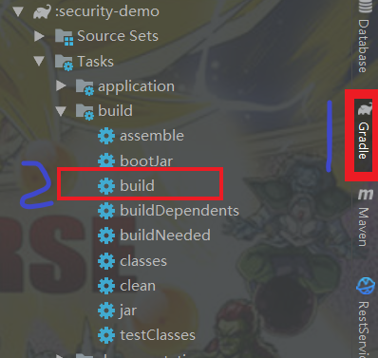

# 2.Restful

## 2.1.区别

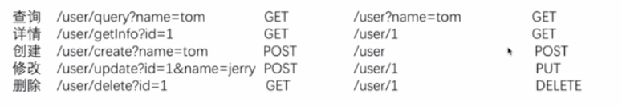

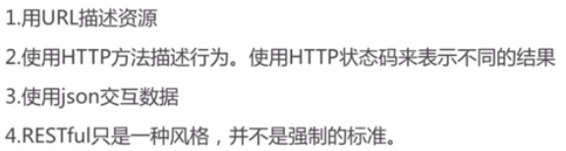

成熟度模型

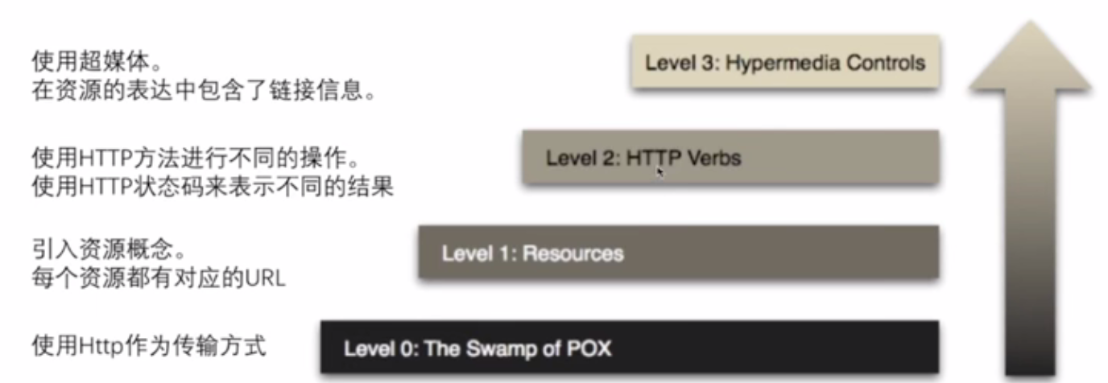

@RequestMapping value(path)参数表示url路径 method表示方法类型

@RequestParam name和value(相同)指定http请求中的参数名 required是否必须

@PageableDefault SpringData Pageable设置默认值

SpringBoot Test UserControllerTest

|  |
| --- |
| @RunWith(SpringRunner.class)//使用SpringRunner执行测试用例  @SpringBootTest  public class UserControllerTest {  @Autowired  private WebApplicationContext wac;  private MockMvc mvc;//伪造的mvc环境  /**  * Before注解在每次测试前都会执行  */  @Before  public void setup() {  mvc = MockMvcBuilders.webAppContextSetup(wac).build();//构建mvc的环境  }  @Test  public void whenQuerySuccess() throws Exception {  mvc.perform(MockMvcRequestBuilders.get("/user")//get的路径  .param("username","冴岛钢牙")//参数  .contentType(MediaType.APPLICATION_JSON_UTF8))//类型  //对上面请求结果的期望， 希望返回状态码是200  .andExpect(MockMvcResultMatchers.status().isOk())  //使用JsonPath判断 返回一个集合，长度为3  .andExpect(MockMvcResultMatchers.jsonPath("$.length()").value(3))  //获取返回 获取Response 转变成String 要设置编码格式  .andReturn().getResponse().getContentAsString();  /*  * response= xxx.getResponse();  * response.setCharacterEncoding("UTF-8");  * String json = response.getContentAsString();  *  }  } |

## 2.2.JsonPath说明

见github; <https://github.com/json-path/JsonPath>

@PathVariable使用正则表达式匹配

|  |
| --- |
| @GetMapping(value = "/user/{id:\\d+}") //匹配数字 public User getUserInfo(@PathVariable(name ="id") String id){ |

## 2.3.JsonView使用

场景：list<User>返回时没有密码， 单个user返回时需要有密码。

使用方法：

### 2.3.1使用接口来声明多个视图

在User类声明接口

|  |
| --- |
| public interface UserSimpleView{}; public interface UserDetailView extends UserSimpleView{}; |

### 2.3.2在值对象的get方法上指定视图

|  |
| --- |
| 由于使用lombok，直接在属性上加  @JsonView(UserSimpleView.class) private String username; @JsonView(UserDetailView.class) private String password; @JsonView(UserSimpleView.class) private int age; |

### 2.3.3在controller方法上指定视图

|  |
| --- |
| @RequestMapping(value = "/user",method = RequestMethod.GET) @JsonView(User.UserSimpleView.class) public List<User> queryUser(){}  @GetMapping(value = "/user/{id:\\d+}")  @JsonView(User.UserDetailView.class)  public User getUserInfo(){} |

List返回 单个对象User

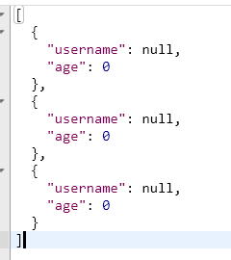 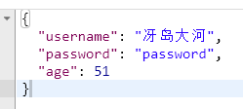

## 2.4.@Valid 参数校验,

### 2.4.1校验

在controller的方法的参数的对象前加上该注解会校验

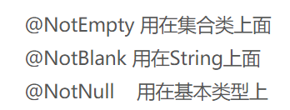

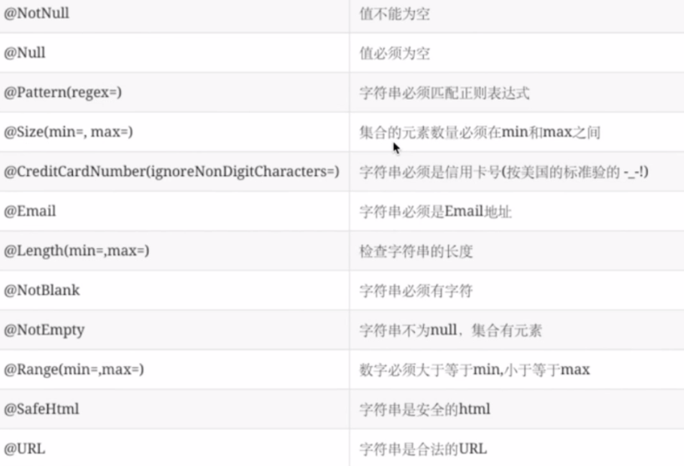

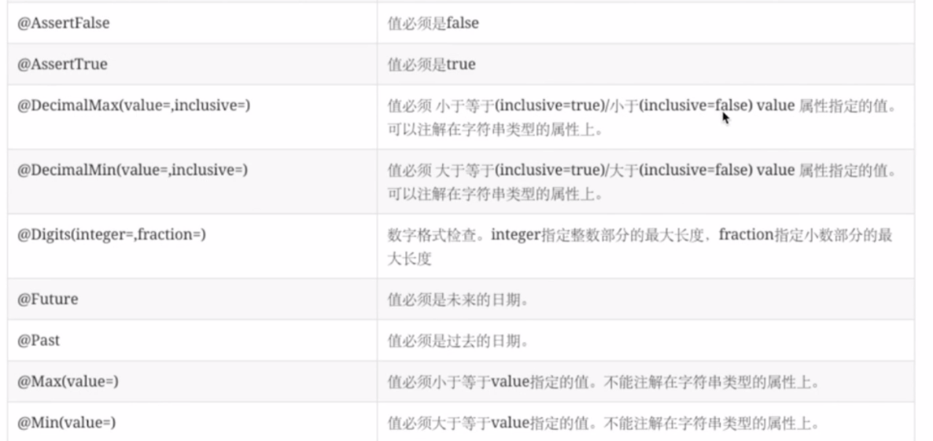

当不符合数据规范时将抛出异常：

org.springframework.web.bind.MethodArgumentNotValidException

使用全局切面处理异常@ControllerAdvice

|  |
| --- |
| @ControllerAdvice  public class CheckAdvice {  @ExceptionHandler(MethodArgumentNotValidException.class)  public ResponseEntity<String> handleBindException(  MethodArgumentNotValidException e) {  return new ResponseEntity<String>(toStr(e), HttpStatus.BAD_REQUEST);  }  private String toStr(MethodArgumentNotValidException ex) {  return ex.getBindingResult().getFieldErrors().stream()  .map(e->e.getDefaultMessage()) .reduce("",(s1,s2)->s1+"\n"+s2); }  } |

### 2.4.2.自定义校验

自定义校验注解

首先创建注解

|  |
| --- |
| @Target({ METHOD, FIELD})  @Retention(RUNTIME)  @Constraint(validatedBy = { MyConstraintValidator.class})//指定执行哪个类  public @interface MyValidatorAnnotation {  String message() default "你是没有继承牙狼称号的人";  Class<?>[] groups() default { };  Class<? extends Payload>[] payload() default { };  String prefix() default "冴岛";  } |

之后创建执行类

|  |
| --- |
| public class MyConstraintValidator implements ConstraintValidator< MyValidatorAnnotation, Object> {  //可以直接使用 @Autowired 注解，而不需要在类上加 @Component  private String prefix;  @Override  public void initialize(MyValidatorAnnotation constraintAnnotation) {  System.out.println("自定义注解校验类开始初始化");  //这里获取注解的信息 例如Range的min， max。在本类中添加相关的字段max,min，然后获取constraintAnnotation信息，赋值。在校验方法里，使用校验  prefix=constraintAnnotation.prefix();  }  @Override  public boolean isValid(Object value, ConstraintValidatorContext context) {  System.out.println("自定义注解开始校验");  System.out.println(value); //这是要校验的值，比如用在username上，那就是username的值  if("".equals(prefix)){  return true;  }  if(value==null ||"".equals(value)){  return false;  }  return value.indexOf(prefix)==0;  }  } |

之后在相关位置使用注解即可。

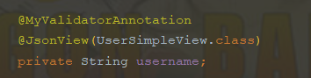判断用户名的前缀，默认是冴岛

Spring Boot有默认的处理机制 一般出现异常会根据是否是浏览器请求，返回不同的格式。

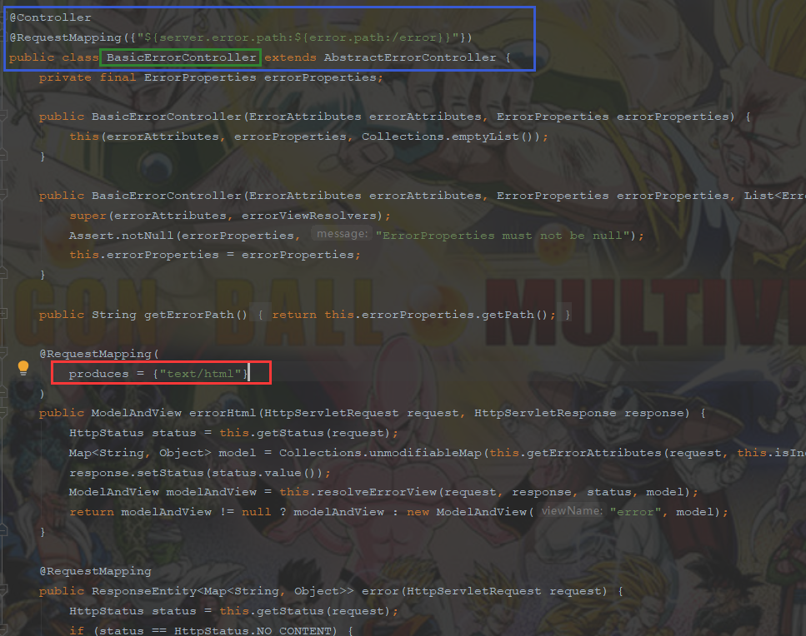

自定义404页面,在resources文件下创建 resources\error文件夹 创建404.html 当浏览器访问路径404时，会返回404页面

## 2.5.Restful Api拦截

过滤器(Filter),拦截器(Interceptor),切片(Aspect)

### 2.5.1过滤器

1. 创建一个过滤器继承javax.servlet.Filter

|  |
| --- |
| @Component //将过滤器加入Spring Boot 中  @Slf4j  public class TimeFilter implements Filter {  @Override  public void init(FilterConfig filterConfig) throws ServletException {  log.info("TimeFilter.init");  }  @Override  public void doFilter(ServletRequest request, ServletResponse response, FilterChain chain) throws IOException, ServletException {  log.info("TimeFilter.doFilter");  log.info("start");  long startTime=System.currentTimeMillis();  chain.doFilter(request,response); //执行controller中的方法  log.info("filter time:"+(System.currentTimeMillis()-startTime)+"ms");  log.info("end");  }  @Override  public void destroy() {  log.info("TimeFilter.destroy");  }  } |

2.使用第三方过滤器 无法使用@Component注解时，手动配置。

创建一个config类，使用@Configuration注解 在该类中配置一个bean(相当于以前的web.xml配置)不能获取controller信息。

|  |
| --- |
| @Configuration //上面过滤器不能有@Component  public class WebConfig {  @Bean  public FilterRegistrationBean timeFilter(){  FilterRegistrationBean bean=new FilterRegistrationBean();  TimeFilter filter=new TimeFilter();  bean.setFilter(filter);  //过滤路径 多个  List<String> urls=new ArrayList<>();  urls.add("/user/*");  bean.setUrlPatterns(urls);  return bean;  }} |

### 2.5.2.使用拦截器

可以获取到controller的信息

创建拦截器 实现HandlerInterceptor接口的三个方法，并使用注解@Component

|  |
| --- |
| @Component  public class TimeInterceptor implements HandlerInterceptor {  @Override  public boolean preHandle(HttpServletRequest request, HttpServletResponse response, Object handler) throws Exception {  log.info("TimeInterceptor.preHandle");  log.info(((HandlerMethod)handler).getBean().getClass().getName());  log.info(((HandlerMethod)handler).getMethod().getName());  request.setAttribute("startTime", System.currentTimeMillis());  return false;  }  @Override  public void postHandle(HttpServletRequest request, HttpServletResponse response, Object handler, ModelAndView modelAndView) throws Exception {  log.info("TimeInterceptor.postHandle");  Long time = (Long) request.getAttribute("startTime");  log.info("耗时："+(System.currentTimeMillis()-time));  }  @Override  public void afterCompletion(HttpServletRequest request, HttpServletResponse response, Object handler, Exception ex) throws Exception {  log.info("TimeInterceptor.afterCompletion");  Long time = (Long) request.getAttribute("startTime");  log.info("耗时："+(System.currentTimeMillis()-time));  log.info("ex is ="+ex);  }  } |

之后创建一个config类(使用上面的WebConfig类)实现WebMvcConfigurer接口(原先：继承WebMvcConfigurerAdapter类过期)

|  |
| --- |
| @Configuration  public class WebConfig implements WebMvcConfigurer {  @Autowired  private TimeInterceptor timeInterceptor;  @Autowired  private TimeInterceptor2 timeInterceptor2;  @Override  public void addInterceptors(InterceptorRegistry registry) {  // timeInterceptor比timeInterceptor2先执行  //添加拦截器 registry.addInterceptor*(*timeInterceptor*)* //指定顺序 order越小优先级越高  .order*(*1*)* //指定路径  .addPathPatterns*(*"/user"*)*; registry.addInterceptor*(*timeInterceptor2*)*.order*(*2*)*.addPathPatterns*(*"/user"*)*;  }  } |

拦截器的执行顺序 1

|  |  |  |
| --- | --- | --- |
| 优先级高的preHandle | | |
| return true | | return false |
| 优先级低的preHandle | | 默认状态码200，无内容 |
| return true | return false |  |
| controller | 优先级高的afterCompletion | / |
| 优先级低的postHandle | 默认状态码200，无内容 | / |
| 优先级高的postHandle | / | / |
| View渲染 | / | / |
| 优先级低的afterCompletion | / | / |
| 优先级高的afterCompletion | / | / |

拦截器的执行顺序 2

|  |
| --- |
| 优先级高的preHandle |
| return true | |
| 优先级低的preHandle | |
| return true | |
| Controller方法 | |
| Controller方法发生异常 | |
| 优先级低的afterCompletion | |
| 优先级高的afterCompletion | |

拦截器的执行顺序 3

|  |  |
| --- | --- |
| 优先级高的preHandle | |
| return true | return false |
| 优先级低的preHandle报异常 | 默认状态码200，无内容 |
| 优先级高的afterCompletion | / |
| 返回异常信息 | / |

拦截器的执行顺序 4

|  |
| --- |
| 优先级高的preHandle |
| 优先级低的preHandle |
| controller |
| 优先级低的postHandle抛出异常 |
| View渲染 |
| 优先级低的afterCompletion(可以获取到异常) |
| 优先级高的afterCompletion (可以获取到异常) |
| 返回状态码200 controller返回的内容, 后台打印异常信息 |

拦截器的执行顺序 5

|  |
| --- |
| 优先级高的preHandle |
| 优先级低的preHandle |
| controller |
| 优先级低的postHandle |
| 优先级高的postHandle |
| View渲染 |
| 优先级低的afterCompletion 抛出异常 后台打印异常信息 |
| 优先级高的afterCompletion (获取不到到异常) |
| 返回状态码200 controller返回的内容 |

如果controller中出现异常被@ControllerAdvice注解的类处理后，afterCompletion不会检测到异常类信息, 但是postHandle不会执行。

路径匹配问题

|  |  |
| --- | --- |
| ? | 匹配任何单字符 |
| * | 匹配0或者任意数量的字符 |
| ** | 匹配0或者更多的目录 |

例如 /user* 能匹配 /user /user1 /userasd 不能匹配 /user/1

/user/** 能匹配 /user /user/dsad /user/1123/45 不能匹配 /user2

/user** 同/user*

/user*/** 能匹配 /user /user1 /user/ds /user12/ds /user/sd/fdfd 全能匹配

拦截器的缺点，无法拿到controller方法中的参数对象的值。

原理DispatcherServlet的doService调用了doDispatch()方法

doDispatch方法中有一下方法

|  |
| --- |
| //先调用拦截器preHandle方法，如果返回false直接结束  if (!mappedHandler.applyPreHandle(processedRequest, response)) {   return; } // Actually invoke the handler 数据拼装在这步  mv = ha.handle(processedRequest, response, mappedHandler.getHandler()); |

### 2.5.3.使用切面

添加切面依赖

|  |
| --- |
| compile "org.springframework.boot:spring-boot-starter-aop:${springBootVersion}" |

创建切面

|  |
| --- |
| @Aspect  @Component  public class TimeAspect {  @Before //类似拦截器的preHandle  @After //类似拦截器的postHandle  @AfterThrowing //类似拦截器的afterCompletion  //包围，覆盖了前3种方式(RequestMapping包含GetMapping和PostMapping一样)定义了在什么方法上起作用，在什么时候起作用  @Around("execution(* com.swb.security.demo.controller.UserController.*(..))")  public Object handleControllerMethod(ProceedingJoinPoint pjp) throws Throwable {  log.info("TimeAspect.handleControllerMethod");  Object[] args = pjp.getArgs(); //获取参数，  for (Object arg:args){  System.out.println(arg);  }  log.info("============================");  //controller方法返回的对象，调用该方法才执行controller的方法  Object o=pjp.proceed();  log.info("============================");  System.out.println(o);  return o;  }  } |

Around 括号内填写相关表达式 详见例子

https://docs.spring.io/spring/docs/5.2.4.RELEASE/spring-framework-reference/core.html#aop-pointcuts-examples

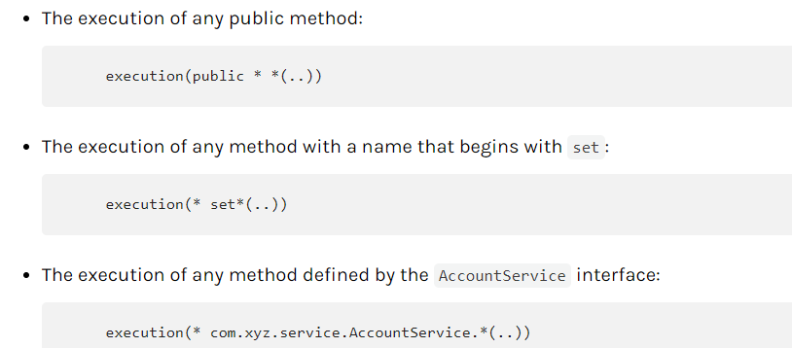

三者比较

|  |  |  |
| --- | --- | --- |
|  | 好处 | 坏处 |
| Filter(过滤器) | 能拿到原始的http请求信息 | 拿不到处理请求的方法信息 |
| Interceptor(拦截器) | 能拿到原始的http请求信息  能拿到处理请求的方法信息 | 拿不到调用时的参数值 |
| Aspect(切面) | 能拿到调用时的参数值 | 拿不到http请求信息  拿不到处理请求的方法信息 |

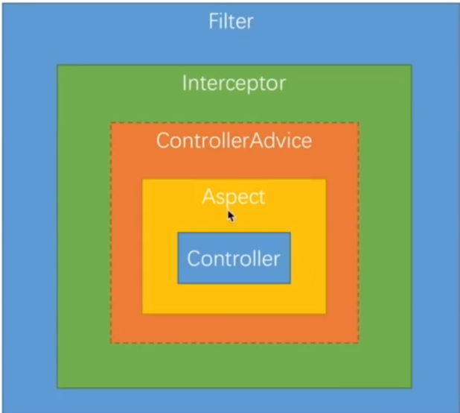

## 2.6.上传下载

application.yml配置

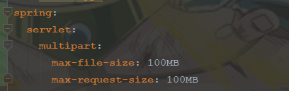 

Controller

|  |
| --- |
| @RestController  @RequestMapping("/files")  public class FileController {  @Value("${filePath}")  private String filePath;  @PostMapping  public FileInfo fileUpload(HttpServletRequest request, @RequestParam(value = "file", required = false) MultipartFile file) throws IOException {  System.out.println(file.getName());  System.out.println(file.getOriginalFilename());  System.out.println(file.getSize());  // file.getInputStream();获取输入流  String fileName = System.currentTimeMillis() + ".txt";  File loadFile = new File(filePath, fileName);  file.transferTo(loadFile);  return new FileInfo("/file/" + fileName);  }  } |

文件下载问题

|  |
| --- |
| //使用静态拦截方法,创建配置类，注解Configuration 实现WebMvcConfigurer  //重写addResourceHandlers方法 txt和图片需要另存为  @Override  public void addResourceHandlers(ResourceHandlerRegistry registry) {  //映射文件地址  registry.addResourceHandler("/file/**").addResourceLocations("file:" + filePath);  } |
| //controller方法 获取文件输入流，输出到response中，设置ContentType为下载  @GetMapping("/{id}")  public void download(@PathVariable String id, HttpServletResponse response) throws Exception {  try (InputStream inputStream = new FileInputStream(new File(filePath, id + ".txt"));  OutputStream outputStream = response.getOutputStream();) {  response.setContentType ("application/x-download");  response.addHeader("Content-Disposition", "attachment;filename=test.txt");  IOUtils.copy(inputStream, outputStream);  outputStream.flush();  }  } |

## 2.7.异步处理Rest服务

使用Runnable异步处理,使用DeferredResult异步处理，异步处理配置

异步处理增加吞吐量

### 2.7.1使用Runnable异步处理

|  |
| --- |
| @RestController @Slf4j public class AsyncController {  @GetMapping("/order")  public Callable<String> order() throws InterruptedException {  log.info("主线程开始");  Callable<String> callable=()->{  log.info("副线程开始");  Thread.sleep(1000L);  log.info("副线程结束");  return "order";  };  log.info("主线程结束");  return callable;  } } |
|  |

客户端拿到的数据的时间还是1000ms之后,tomcat主线程结束很快，可以处理之后的Http请求,副线程处理完后，再返回结果。

### 2.7.2使用DeferredResult异步处理

使用Runnable处理时实在controller方法中创建Callable处理的,有主线程调用副线程

DeferredResult使用场景

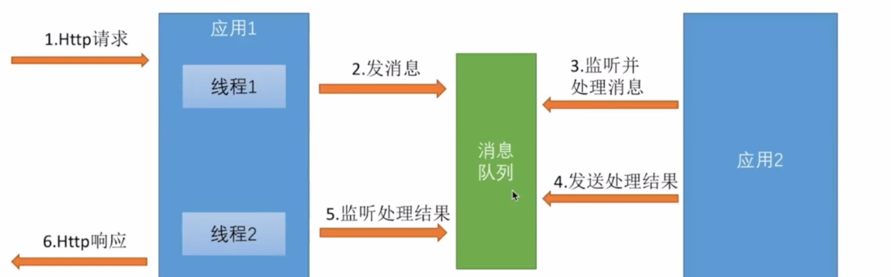

创建一个模拟队列,即消息队列和应用2

|  |
| --- |
| @AllArgsConstructor  @NoArgsConstructor  @Slf4j  @Component  public class MockQueue {  private String placeOrder;  private String completeOrder;  public String getPlaceOrder() {  return placeOrder;  }  //重要方法  public void setPlaceOrder(String placeOrder) {  new Thread(()->{  log.info("接到下单请求:" + placeOrder);  try {  Thread.sleep(1000L);  this.completeOrder = placeOrder;  } catch (InterruptedException e) {  e.printStackTrace();  }  log.info("下单请求:"+placeOrder+"处理完毕");  }).start();  }  public String getCompleteOrder() {  return completeOrder;  }  public void setCompleteOrder(String completeOrder) {  this.completeOrder = completeOrder;  }  } |

创建DeferredResultHolder在应用1的2个线程中传递DeferredResult对象

|  |
| --- |
| @Component  @Data  public class DeferredResultHolder {  /**  * map中的String 是订单号  * DeferredResult<String>是处理结果  */  private Map<String, DeferredResult<String>> map=new HashMap<String, DeferredResult <String>>();  } |

创建应用1的线程1,即相应的Http请求

|  |
| --- |
| @RestController  @Slf4j  @AllArgsConstructor  public class AsyncController {  private MockQueue mockQueue; private DeferredResultHolder deferredResultHolder;  @GetMapping("/order2") public DeferredResult<String> order2() {  log.info("主线程开始");  String orderNumber= RandomStringUtils.randomNumeric(10);  mockQueue.setPlaceOrder(orderNumber);  DeferredResult<String> result=new DeferredResult<>();  deferredResultHolder.getMap().put(orderNumber,result);  log.info("主线程结束");  return result; }  } |

创建队列监听器，即应用1的线程2

|  |
| --- |
| @Component  @Slf4j  @AllArgsConstructor  public class QueueListener implements ApplicationListener<ContextRefreshedEvent> {  private MockQueue mockQueue;  private DeferredResultHolder deferredResultHolder;  @SuppressWarnings("AlibabaAvoidManuallyCreateThread")  @Override  public void onApplicationEvent(ContextRefreshedEvent event) {  //noinspection AlibabaAvoidManuallyCreateThread  new Thread(()->{  while (true){  if (StringUtils.isNotBlank(mockQueue.getCompleteOrder())){  String orderNumber=mockQueue.getCompleteOrder();  log.info("返回订单处理结果");  //当调用setResult方法时，返回处理结果  deferredResultHolder.getMap().get(orderNumber).setResult("order");  mockQueue.setCompleteOrder(null);  }else{  try {  Thread.sleep(1000L);  } catch (InterruptedException e) {  e.printStackTrace();  }  }  }  }).start();  }  } |

bean注入方式，除@Autowired外，使用构造方法时，不能有无参构造函数，只能一个构造函数，包含所有要注入的bean，可以使用lombok的@AllArgsConstructor注解

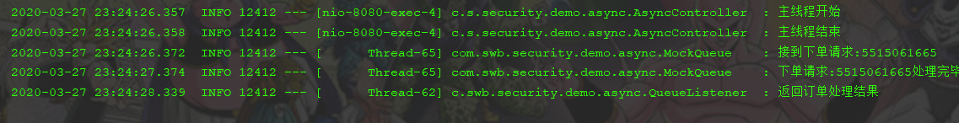

Tomcat的一个线程接受请求，之后由另一个线程处理，最后由第三个线程返回。而tomcat的线程早就结束了，可以处理新的请求。

前端拿到数据的时间是最后第三个线程的调用DeferredResult. setResult()方法的时间。

异步处理配置

WebConfig实现的WebMvcConfigurer接口的一个方法configureAsyncSupport其参数AsyncSupportConfigurer 主要配置异步的拦截器，超时时间，指定Runnable使用的线程池。

## 2.8使用swagger生产文档

demo添加依赖

|  |
| --- |
| compile group: 'io.springfox', name: 'springfox-swagger2', version: "${springfoxVersion}" compile group: 'io.springfox', name: 'springfox-swagger-ui', version: "${springfoxVersion}" |

在SpringBoot启动类上添加@EnableSwagger2注解

启动项目访问：<http://localhost:8080/swagger-ui.html>

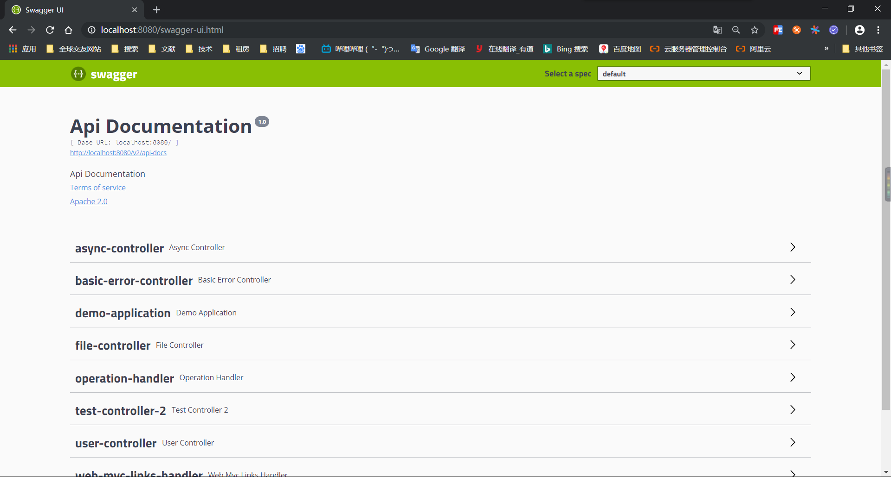

点击user-controller下方展示所有的请求

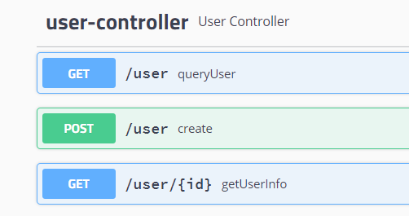

点击请求展示相关示例

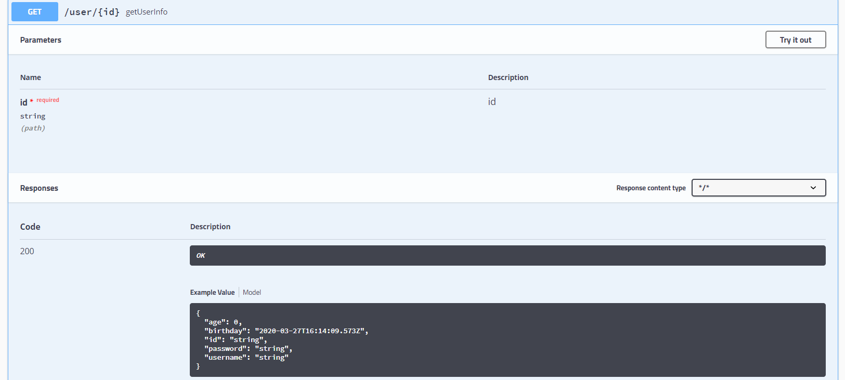

以上都是默认显示，如请求后面显示方法名,对请求进行描述：在方法上添加注解



对参数写注解，如果参数是对象那么在对象上的属性写注解@ApiModelProperty



对于参数为基本类型的注解

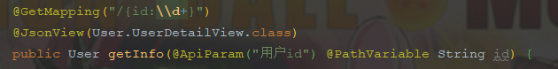

Json返回对象时，也在属性上添加注解ApiModelProperty

详见swagger文档。

## 2.9.wiremock

使用wiremock伪造假数据

官网下载wiremock的jar包：<http://wiremock.org/docs/running-standalone/>

demo中添加wiremock依赖

|  |
| --- |
| testCompile group: 'com.github.tomakehurst', name: 'wiremock', version: '2.26.3', ext: 'pom' |

在test包下创建MockServer类

|  |
| --- |
| public class MockServer {  //添加一个url(/order/1 ,返回withBody里的json值，状态码200),运行main方法即可  public static void main(String[] args) {  //端口  configureFor(8062);  removeAllMappings();  stubFor(get(urlPathEqualTo("/order/1"))  .willReturn(aResponse().withBody("{\"id\":1}").withStatus(200)));  }  } |

访问<http://localhost:8060/order/1> 将返回 json 

使用详情见官网

# 3. Spring Security认证

## 3.1说明

核心功能：认证(你是谁-登录)，授权(能做什么)，攻击防护(防止伪造身份)

打开demo的security配置,在启动类上删除SpringBootApplication注解上的exclude内容中的Security相关类。

启动Demo,访问<http://localhost:8080/user>时，出现登录提示，登录后才能访问。

在browser中添加一个Security的配置类，重写Http请求时的配置

|  |
| --- |
| @Configuration  @Slf4j  public class BrowserSecurityConfig extends WebSecurityConfigurerAdapter {  @Override  protected void configure(HttpSecurity http) throws Exception {  log.info("BrowserSecurityConfig.configure");  // 指定身份认证的方式 表单登录  http.formLogin()  // basic方式认证  // http.httpBasic()  .and()  // 开始请求权限配置  .authorizeRequests()  // 下面2行是对http所有的请求必须通过授权认证才可以访问  // 对任何请求  .anyRequest()  // 都需要身份验证  .authenticated();  }  } |

Demo引用了core和Browser，因此在Browser中配置，可以供其他模块使用，并且可以提取出来给后续功能点使用。

Demo启动类位于com.swb.security.demo包下，而briwser都位于com.swb.security.browser包下，因此需要在config类(添加了@Configuration注解的类)上添加注解,指定额外扫描某个包,或者将启动类放到com.swb.security包下。@ComponentScan(basePackages = { "com.swb.security.browser"})，查看是否加载到可以在方法中添加一行日志

Form登录方式

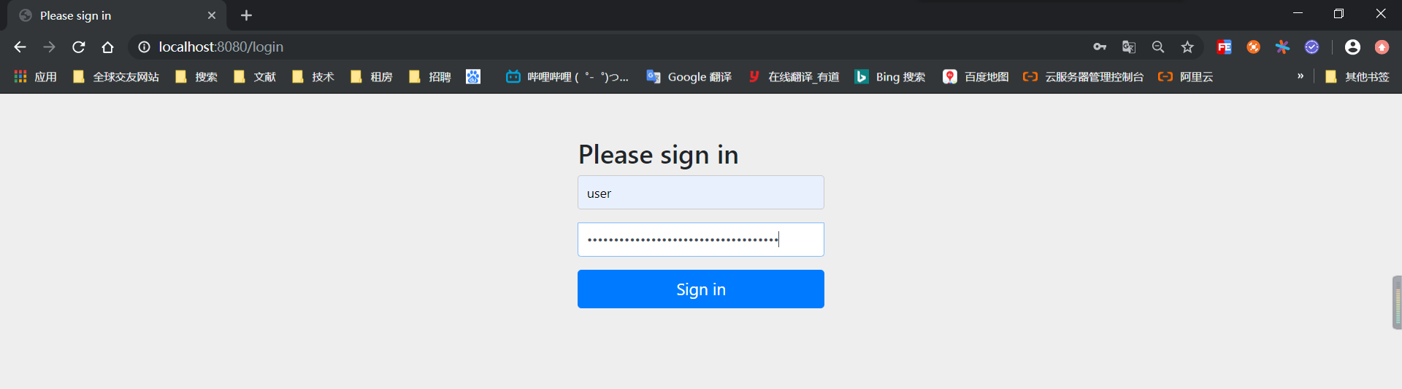

httpBasic方式登录

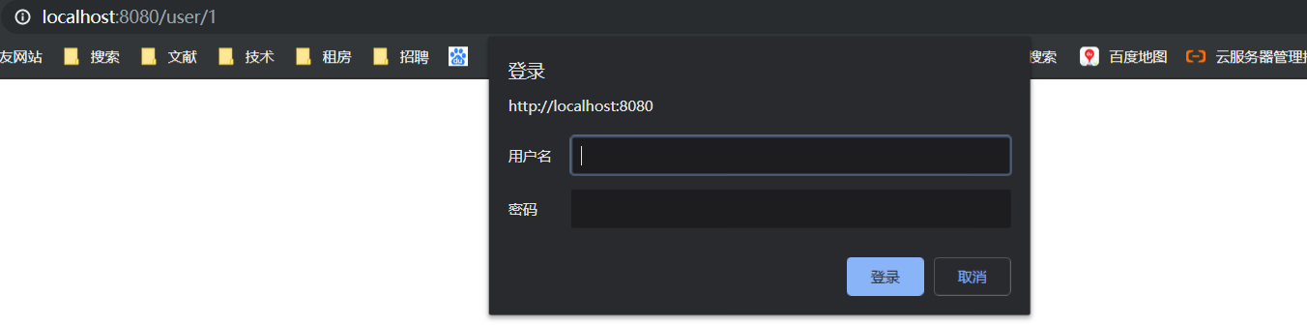

默认是

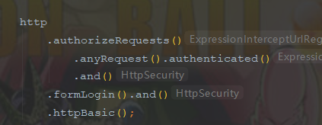

Security过程

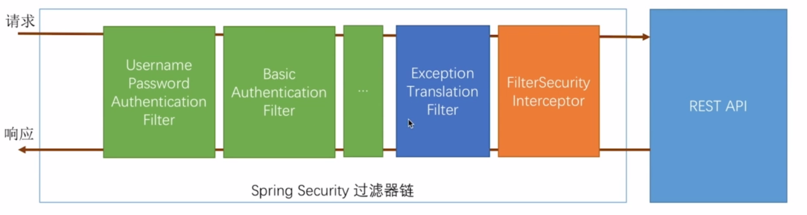

绿色的为所有认证用户身份使用。每种过滤器处理一种登录方式。只要有一个认证通过，该请求会被标记，表示请求认证成功，如果不成功，继续下一个过滤器。

当认证成功后，有橙色的过滤器判断是否能够访问。如果不能访问，会抛出异常由蓝色过滤器处理，例如没权限，没认证等异常。之后绿色才能修改，比如禁用某个认证。而其他过滤器不能修改。

## 3.2.自定义用户逻辑认证

处理用户信息获取逻辑(从数据库中获取)，处理用户校验逻辑，处理密码加密解密

### 3.2.1处理用户信息获取逻辑

实现UserDetailsService接口 该接口只有一个loadUserByUsername方法。读取用户信息，进行校验。

在browser中实现该接口

|  |
| --- |
| @Component  @Slf4j  public class MyUserDetailsService implements UserDetailsService {  /**  * 注入持久层信息 例如 mybatis的mapper, SpringDataJPA的Repository  * 输入用户名，从数据库中获取数据，这里是模拟获取  * User对象为org.springframework.security.core.userdetails包下的，实现了UserDetails接口  * 参数，用户名，密码，权限List<GrantedAuthority>  * @param username  * @return  * @throws UsernameNotFoundException  */  @Override  public UserDetails loadUserByUsername(String username) throws UsernameNotFoundException {  log.info("MyUserDetailsService.loadUserByUsername");  log.info("登录名为:"+username);  BCryptPasswordEncoder encoder = new BCryptPasswordEncoder();  String password = encoder.encode("123456");  return new User(username,password, AuthorityUtils.commaSeparatedStringToAuthorityList("admin"));  }  } |

Security5需要添加加密处理

在browser的BrowserSecurityConfig中添加配置

|  |
| --- |
| @Bean public PasswordEncoder passwordEncoder() {  // 使用 BCrypt 加密  return new BCryptPasswordEncoder();  } |

1. 用户校验逻辑

分为密码是否匹配(由security处理)，用户是否冻结，是否过期等

由UserDetails提供的4个方法实现

|  |
| --- |
| //账户有没有过期 true没有过期  boolean isAccountNonExpired();  //账户是否锁定 true没有锁定 可表示用户被冻结  boolean isAccountNonLocked();  //密码有没有过期 true没有过期  boolean isCredentialsNonExpired();  //是否可用 true用户可用 可表示用户被删除  boolean isEnabled(); |

使用org.springframework.security.core.userdetails包下的User对象时，可以在构造函数上添加参数，自己定义的类则是重写上述方法。

1. 加密解密处理

加密已再上方添加过来，可以采用BcryptPasswordEncoder加密，也可以自定义加密。

BcryptPasswordEncoder每次加密时，输出的密码都不相同，判断时需要使用matches方法

### 3.2.2.个性化用户认证流程

自定义登录页面,自定义登录成功处理，自定义登录失败处理

#### 3.2.2.1.自定义登录页面

重新修改登录页面，在browser的security中修改相关的配置

|  |
| --- |
| @Override protected void configure(HttpSecurity http) throws Exception {  log.info("BrowserSecurityConfig.configure"); // 指定身份认证的方式 表单登录  http.formLogin()  //指定登录页面  .loginPage("/login.html")  //自定义登录请求路径,默认是post方式的login . loginProcessingUrl("/authentication/form") // basic方式认证 // http.httpBasic()  .and() // 开始请求权限配置  authorizeRequests()  //当前路径不需要认证  .antMatchers("/login.html").permitAll() // 下面2行是对http所有的请求必须通过授权认证才可以访问 // 对任何请求  .anyRequest() // 都需要身份验证  .authenticated().and().csrf().disable(); } |

在browser中添加一个登录页面src\main\resources\resources\login.html

|  |
| --- |
| <form method="post" action="/authentication/form">  <input type="text" id="username" name="username" maxlength="50" placeholder="请输入账号">  <input type="password" id="password" name="password" maxlength="30" placeholder="请输入密码" > |

处理不同类型的请求，html请求或数据请求

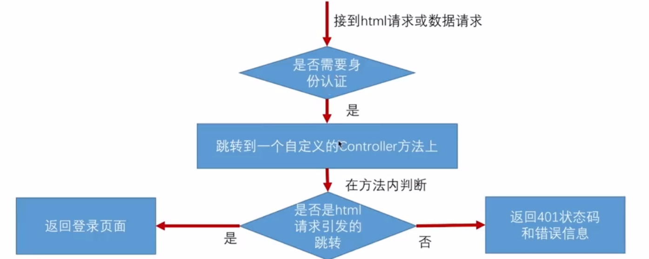

在core中添加配置相关的类,应用于以后的多个系统，配置相关信息

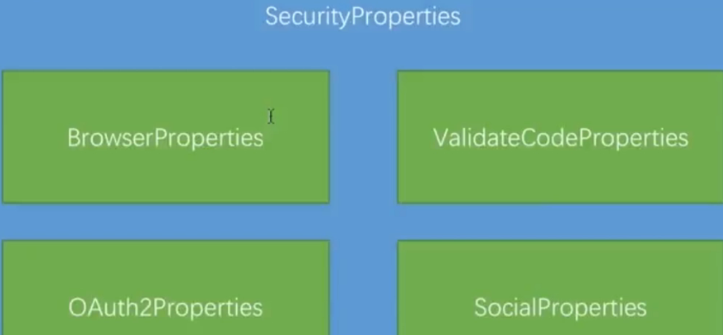

在core中添加SecurityProperties,BrowserProperties

|  |
| --- |
| @Component  @ConfigurationProperties(prefix = "swb.security")  @Data  public class SecurityProperties {  private BrowserProperties browser=new BrowserProperties();  }  @Data  public class BrowserProperties {  //默认值  private String loginPage="/browserLogin.html";  } |

修改browser的securityConfig配置

|  |
| --- |
| @Override protected void configure(HttpSecurity http) throws Exception {  log.info("BrowserSecurityConfig.configure"); // 指定身份认证的方式 表单登录  http.formLogin()  //指定未登录时跳转位置  .loginPage("/authentication/require")  //自定义登录请求路径,默认是post方式的login  .loginProcessingUrl("/authentication/form") // basic方式认证 // http.httpBasic()  .and() // 开始请求权限配置  .authorizeRequests()  //当前路径不需要认证, 未登录时跳转位置,登录页面  .antMatchers("/authentication/require",securityProperties.getBrowser().getLoginPage())  .permitAll() // 下面2行是对http所有的请求必须通过授权认证才可以访问 // 对任何请求  .anyRequest() // 都需要身份验证  .authenticated().and().csrf().disable(); } |

在browser中添加一个controller用于处理请求是否需要跳转

|  |
| --- |
| @RestController @Slf4j public class BrowserSecurityController {  private RequestCache cache=new HttpSessionRequestCache();  private RedirectStrategy redirectStrategy=new DefaultRedirectStrategy();  @Autowired  private SecurityProperties securityProperties;  /**  * 当需要身份认证是跳转到这里  * @param request  * @param response  * @return  */  @RequestMapping("/authentication/require")  @ResponseStatus(code= HttpStatus.UNAUTHORIZED)  public SimpleResponse requireAuthentication(HttpServletRequest request,  HttpServletResponse response) throws IOException {  SavedRequest savedRequest=cache.getRequest(request,response);  if(savedRequest!=null){  String target=savedRequest.getRedirectUrl();  log.info("引发跳转的请求是："+target);  if(StringUtils.endsWithIgnoreCase(target,".html")){  //跳转路径 redirectStrategy.sendRedirect(request,response,securityProperties.getBrowser().getLoginPage());  }  }  return new SimpleResponse("访问信息需要身份认证");  } } |

当未登录时，如果访问的是数据(未以.html结尾时)返回401信息，如果是页面，返回登录页面。当application.yml中未配置swb.security.browser.loginPage值时，默认登录页面是browser，当指定某个值时，跳转到该页面。

#### 3.2.2.2.自定义登录成功处理

在browser中实现AuthenticationSuccessHandler接口

|  |
| --- |
| @Component("swbSecurityAuthenticationSuccessHandler")  @Slf4j  public class SecurityAuthenticationSuccessHandler implements AuthenticationSuccessHandler {  //json转化  @Autowired  private ObjectMapper objectMapper;  /**  * @param request  * @param response  * @param authentication security核心接口,封装了一些认证信息(包括请求的ip,session,UserDetails)  * @throws IOException  * @throws ServletException  */  @Override  public void onAuthenticationSuccess(HttpServletRequest request, HttpServletResponse response, Authentication authentication) throws IOException, ServletException {  log.info("SecurityAuthenticationSuccessHandler.onAuthenticationSuccess:登录成功");  //将authentication转化为json返回  response.setContentType(MediaType.APPLICATION_JSON_UTF8_VALUE);  response.getWriter().write(objectMapper.writeValueAsString(authentication));  }  } |

在browser的security中添加配置

|  |
| --- |
| @Configuration  @Slf4j  public class BrowserSecurityConfig extends WebSecurityConfigurerAdapter {  @Autowired  private SecurityProperties securityProperties;  @Autowired  @Qualifier("swbSecurityAuthenticationSuccessHandler")  private AuthenticationSuccessHandler successHandler;  @Override  protected void configure(HttpSecurity http) throws Exception {  log.info("BrowserSecurityConfig.configure");  // 指定身份认证的方式 表单登录  http.formLogin()  //指定登录页面  .loginPage("/authentication/require")  //自定义登录请求路径,默认是post方式的login  .loginProcessingUrl("/authentication/form")  //登录成功自定义处理注入  .successHandler(successHandler)  // basic方式认证  // http.httpBasic()  .and()  // 开始请求权限配置  .authorizeRequests()  //当前路径不需要认证  .antMatchers("/authentication/require",securityProperties.getBrowser().getLoginPage())  .permitAll()  // 下面2行是对http所有的请求必须通过授权认证才可以访问  // 对任何请求  .anyRequest()  // 都需要身份验证  .authenticated().and().csrf().disable();  }  @Bean  public PasswordEncoder passwordEncoder() {  // 使用 BCrypt 加密  return new BCryptPasswordEncoder();  }  } |

登录之后页面返回一下json格式,会根据登录方式不同，而返回不同的方式

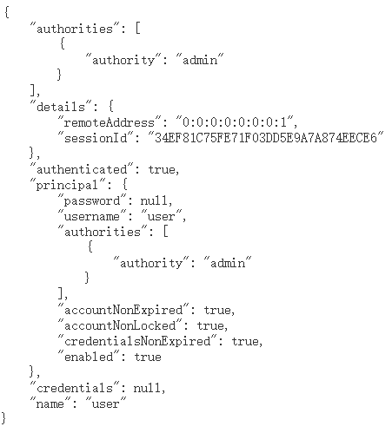

#### 3.2.2.3.登录错误处理(与成功类似)

Browser中实现AuthenticationFailureHandler接口

|  |
| --- |
| @Component("swbSecurityAuthenticationFailureHandler")  @Slf4j  public class SecurityAuthenticationFailureHandler implements AuthenticationFailureHandler {  @Autowired  private ObjectMapper objectMapper;  @Override  public void onAuthenticationFailure(HttpServletRequest request, HttpServletResponse response, AuthenticationException exception) throws IOException, ServletException {  log.info("SecurityAuthenticationFailureHandler.onAuthenticationFailure:登录失败");  //将authentication转化为json返回  response.setStatus(HttpStatus.INTERNAL_SERVER_ERROR.value());  response.setContentType(MediaType.APPLICATION_JSON_UTF8_VALUE);  response.getWriter().write(objectMapper.writeValueAsString(exception));  }  } |

SecurityConfig中添加配置

|  |
| --- |
| …………  @Autowired @Qualifier("swbSecurityAuthenticationFailureHandler") private AuthenticationFailureHandler failureHandler;  …………  //登录成功自定义处理注入 .successHandler(successHandler) //登录失败自定义处理注入 .failureHandler(failureHandler)  ………… |

#### 3.2.2.4.多种返回格式

上述修改之后便是全部变成返回json

之后修改变成同时支持2种方式

在core中添加一个枚举，并在browser中添加一个属性

|  |
| --- |
| /**  * @author swb  * 时间 2020-03-30 00:23  * 文件 LoginType  */  public enum LoginType {  /**  * 跳转  */  REDIRECT,  /**  * 返回json  */  JSON  }  BrowserProperties{……  private LoginType loginType = LoginType.JSON; ……} |

修改自定义的成功处理器，不实现接口，改为继承已实现默认的处理器SavedRequestAwareAuthenticationSuccessHandler

|  |
| --- |
| @Component("swbSecurityAuthenticationSuccessHandler")  @Slf4j  @AllArgsConstructor  public class SecurityAuthenticationSuccessHandler extends SavedRequestAwareAuthenticationSuccessHandler {  private ObjectMapper objectMapper;  private SecurityProperties securityProperties;  /**  * @param request  * @param response  * @param authentication security核心接口,封装了一些认证信息(包括请求的ip,session,UserDetails)  * @throws IOException  * @throws ServletException  */  @Override  public void onAuthenticationSuccess(HttpServletRequest request, HttpServletResponse response, Authentication authentication) throws IOException, ServletException {  log.info("SecurityAuthenticationSuccessHandler.onAuthenticationSuccess:登录成功");  if (LoginType.JSON.equals(securityProperties.getBrowser().getLoginType())) {  //将authentication转化为json返回  response.setContentType(MediaType.APPLICATION_JSON_UTF8_VALUE);  response.getWriter().write(objectMapper.writeValueAsString(authentication));  } else {  super.onAuthenticationSuccess(request, response, authentication);  }  }  } |

登录失败继承SimpleUrlAuthenticationFailureHandler类

默认为JSON, application.yml的配置

|  |
| --- |
| swb.security.browser.loginType: REDIRECT  swb.security.browser.loginType: JSON |

#### 3.2.2.5.获取用户信息

获取用户的信息 上面的2种方法包含登录的其他信息，下面的方法只包含user信息(数据库中的信息)

|  |
| --- |
| @GetMapping("/security/me") public Object getCurrentUser(){  return SecurityContextHolder.getContext().getAuthentication(); } |
| @GetMapping("/security/me2") public Object getCurrentUser2(Authentication authentication){  return authentication; } |
| @GetMapping("/security/me3") public Object getCurrentUser2(@AuthenticationPrincipal UserDetails user){  return user; } |

## 3.3图片验证码

### 3.3.1实现图片验证码

开发生产图形验证码接口，在认证流程中加入图形验证码校验，重构代码

生产图形原验证码：随机数生成图片；将随机数存放到Session（redis）中；将生成的图片写道接口的响应中，展示到前端

写在core中，加入hutool(github上的)依赖

创建imageCode，实现AbstractCaptcha接口，加入过期时间属性(时间类)其他同其提供的CircleCaptcha实现类相同，也可以直接使用以提供的实现类

|  |
| --- |
| public class ImageCode extends AbstractCaptcha {  @Setter  @Getter  private LocalDateTime expireTime;  private static final long serialVersionUID = 3180820918087507384L;  /**  * 构造  *  * @param width 图片宽  * @param height 图片高  */  public ImageCode(int width, int height) {  this(width, height, 5);  }  /**  * 构造  *  * @param width 图片宽  * @param height 图片高  * @param codeCount 字符个数  */  public ImageCode(int width, int height, int codeCount) {  this(width, height, codeCount, 15, 300);  }  /**  * 构造  *  * @param width 图片宽  * @param height 图片高  * @param codeCount 字符个数  * @param interfereCount 验证码干扰元素个数  * @param expireIn 过期秒数  */  public ImageCode(int width, int height, int codeCount, int interfereCount, int expireIn) {  super(width, height, codeCount, interfereCount);  this.expireTime = LocalDateTime.now().plusSeconds(expireIn);  }  @Override  public Image createImage(String code) {  final BufferedImage image = new BufferedImage(width, height, BufferedImage.TYPE_INT_RGB);  final Graphics2D g = ImgUtil.createGraphics(image, ObjectUtil.defaultIfNull(this.background, Color.WHITE));  // 随机画干扰圈圈  drawInterfere(g);  // 画字符串  drawString(g, code);  return image;  }  // ----------------------------------------------------------------------------------------------------- Private method start  /**  * 绘制字符串  *  * @param g {@link Graphics}画笔  * @param code 验证码  */  private void drawString(Graphics2D g, String code) {  // 指定透明度  if (null != this.textAlpha) {  g.setComposite(this.textAlpha);  }  GraphicsUtil.drawStringColourful(g, code, this.font, this.width, this.height);  }  /**  * 画随机干扰  *  * @param g {@link Graphics2D}  */  private void drawInterfere(Graphics2D g) {  final ThreadLocalRandom random = RandomUtil.getRandom();  for (int i = 0; i < this.interfereCount; i++) {  g.setColor(ImgUtil.randomColor(random));  g.drawOval(random.nextInt(width), random.nextInt(height), random.nextInt(height >> 1), random.nextInt(height >> 1));  }  }  public boolean isExpried() {  return LocalDateTime.now().compareTo(expireTime) >= 0;  } } |

core中创建controller

|  |
| --- |
| @RestController  public class ValidateCodeController {  private static final String SESSION_KEY = "SESSION_KEY_IMAGE_CODE";  private SessionStrategy sessionStrategy = new HttpSessionSessionStrategy();  @GetMapping("/code/image")  public void createCode(HttpServletRequest request, HttpServletResponse response) throws IOException {  ImageCode imageCode = new ImageCode(200, 100, 4, 20,600);  sessionStrategy.setAttribute(new ServletWebRequest(request), SESSION_KEY, imageCode);  imageCode.write(response.getOutputStream());  }  } |

在Browser中，将conreoller中的方法放行(不需要认证)。

访问/code/image即可看到

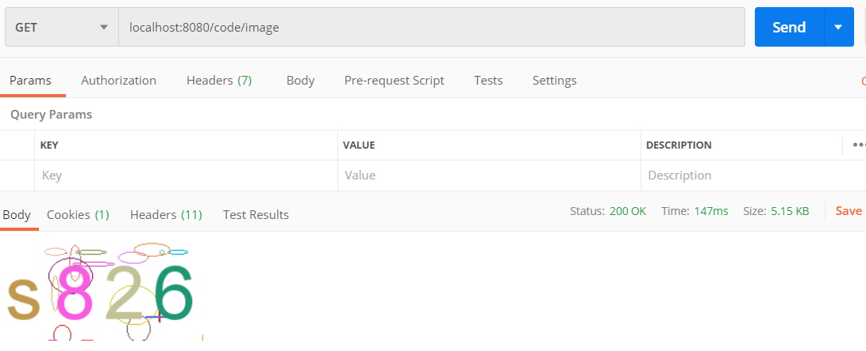

### 3.3.2.验证码校验

创建一个过滤器,在security的UsernamePasswordAuthenticationFilter过滤器之前校验验证码.验证码通过调用UsernamePasswordAuthenticationFilter的过滤器,失败的话返回错误信息.

|  |
| --- |
| @Data  public class ValidateCodeFilter extends OncePerRequestFilter {  private AuthenticationFailureHandler authenticationFailureHandler;  private SessionStrategy sessionStrategy = new HttpSessionSessionStrategy();  @Override  protected void doFilterInternal(HttpServletRequest request, HttpServletResponse response, FilterChain filterChain) throws ServletException, IOException {  //是登陆的post请求  if (AppConst.LOGIN_PATH.equals(request.getRequestURI()) && AppConst.METHOD.equalsIgnoreCase(request.getMethod())) {  try {  validate(new ServletWebRequest(request));  } catch (ValidateCodeException e) {  authenticationFailureHandler.onAuthenticationFailure(request, response, e);  return;  }  }  filterChain.doFilter(request, response);  }  private void validate(ServletWebRequest request) throws ServletRequestBindingException {  ImageCode codeSession = (ImageCode) sessionStrategy.getAttribute(request, AppConst.SESSION_KEY);  String codeRequest= ServletRequestUtils.getStringParameter(request.getRequest(),AppConst.CODE_NAME,"");  if(codeRequest.isEmpty()){  throw new ValidateCodeException("验证码不能为空");  }  if(codeSession==null){  throw new ValidateCodeException("验证码不存在");  }  if(codeSession.isExpried()){  throw new ValidateCodeException("验证码已过期");  }  if(!codeSession.verify(codeRequest)){  throw new ValidateCodeException("验证码错误");  }  sessionStrategy.removeAttribute(request,AppConst.SESSION_KEY);  }  } |

自定义异常类ValidateCodeException

|  |
| --- |
| public class ValidateCodeException extends AuthenticationException {  public ValidateCodeException(String msg) {  super(msg);  }  } |

在browser中修改config，将过滤器加入

|  |
| --- |
| …………………………………  ValidateCodeFilter filter=new ValidateCodeFilter(); filter.setAuthenticationFailureHandler(failureHandler); // 指定身份认证的方式 表单登录 http.addFilterBefore(filter, UsernamePasswordAuthenticationFilter.class).formLogin()  //指定登录页面  .loginPage("/authentication/require")  ………………………………… |

### 3.3.3.图形验证码重构

1. 验证码参数配置(图片长宽，验证长度，过滤接口等)

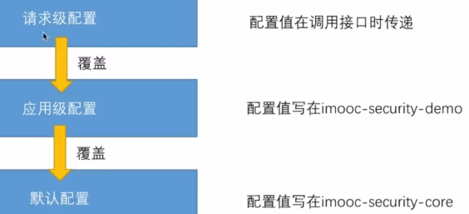

core配置，在properties中添加一个信息的配置信息类ImageCodeProperties(含默认)

|  |
| --- |
| @Data  public class ImageCodeProperties {  private int width=200;  private int height=100;  private int length=4;  private int interfereCount=20;  private int expire=600;  } |

创建ValidateCodeProperties，存放ImageCodeProperties和短信

|  |
| --- |
| @Data  public class ValidateCodeProperties {  private ImageCodeProperties imageCode=new ImageCodeProperties();  } |

在SecurityProperties中加入ValidateCodeProperties

|  |
| --- |
| @Component  @ConfigurationProperties(prefix = "swb.security")  @Data  public class SecurityProperties {  private BrowserProperties browser=new BrowserProperties();  private ValidateCodeProperties validateCode=new ValidateCodeProperties();  } |

以上为应用级配置，在yml中可配置

|  |
| --- |
| swb.security.validateCode.imageCode.length: 5 |

设置请求级配置，在生成验证码图片的controller中修改

|  |
| --- |
| @RestController  public class ValidateCodeController {  @Autowired  private SecurityProperties securityProperties;  private SessionStrategy sessionStrategy = new HttpSessionSessionStrategy();  @GetMapping("/code/image")  public void createCode(HttpServletRequest request, HttpServletResponse response) throws IOException {  ImageCodeProperties codeProperties = securityProperties.getValidateCode().getImageCode();  int width= ServletRequestUtils.getIntParameter(request,"width", codeProperties.getWidth());  int height= ServletRequestUtils.getIntParameter(request,"height", codeProperties.getHeight());  ImageCode imageCode = new ImageCode(width, height, codeProperties.getLength(),  codeProperties.getInterfereCount(),  codeProperties.getExpireIn());  sessionStrategy.setAttribute(new ServletWebRequest(request), AppConst.SESSION_KEY, imageCode);  imageCode.write(response.getOutputStream());  }  } |

在yml中可以指定ImageCode的所有参数，会覆盖默认的参数，在请求中可以包含长宽2个参数，会覆盖yml中配置的参数以及默认的参数。

例如默认验证码数为4，长200，yml中配置验证码数为6，长为300，请求中设置100, 实际结果如下： 请求中不设置参数：

 

1. 动态校验验证码路径

配置验证验证码的过滤路径，即哪些操作需要验证码(如登录，查询敏感信息(个人信息)等)

在ImageCodeProperties中添加一个属性url。在yml中以’,’隔开处理

|  |
| --- |
| private String url; |

验证码过滤器ValidateCodeFilter实现InitializingBean接口，实现初始化bean后的操作(在属性设置之后做的事情)。

|  |
| --- |
| @Data  public class ValidateCodeFilter extends OncePerRequestFilter implements InitializingBean {  private AuthenticationFailureHandler authenticationFailureHandler;  private SessionStrategy sessionStrategy = new HttpSessionSessionStrategy();  private AntPathMatcher pathMatcher=new AntPathMatcher();  private Set<String> urls = new HashSet<>();  private SecurityProperties securityProperties;  @Override  public void afterPropertiesSet() throws ServletException {  super.afterPropertiesSet();  String url = securityProperties.getValidateCode().getImageCode().getUrl();  if(!StringUtils.isEmpty(url)) {//不为空  // //使用Collections加入配置的url到set  // Collections.addAll(urls, url.split(","));  // 使用Stream流  urls = Stream.of(url.split(",")).collect(Collectors.toSet());  }  //加入登录的请求  urls.add(AppConst.LOGIN_PATH);  }  @Override  protected void doFilterInternal(HttpServletRequest request, HttpServletResponse response, FilterChain filterChain) throws ServletException, IOException {  String uri = request.getRequestURI();  //Stream判断哪些路径是需要过滤的，pathMatcher.match判断*等通配符  if (urls.stream().anyMatch(s->pathMatcher.match(s,uri))) {  try {  validate(new ServletWebRequest(request));  } catch (ValidateCodeException e) {  authenticationFailureHandler.onAuthenticationFailure(request, response, e);  return;  }  }  filterChain.doFilter(request, response);  }  ………………………………………………. |

在browser的SecurityConfig中设置filter的属性

|  |
| --- |
| ……………  ValidateCodeFilter filter=new ValidateCodeFilter();  filter.setAuthenticationFailureHandler(failureHandler);  filter.setSecurityProperties(securityProperties);  filter.afterPropertiesSet();  // 指定身份认证的方式 表单登录  http.addFilterBefore(filter, UsernamePasswordAuthenticationFilter.class).formLogin()  ……………………. |

在demo的yml中配置url属性,访问/user没问题,访问/user/12 /user/1提示验证码不能为空

|  |
| --- |
| swb.security.validateCode.imageCode.url: /user/* |

## 3.4记住我功能原理：

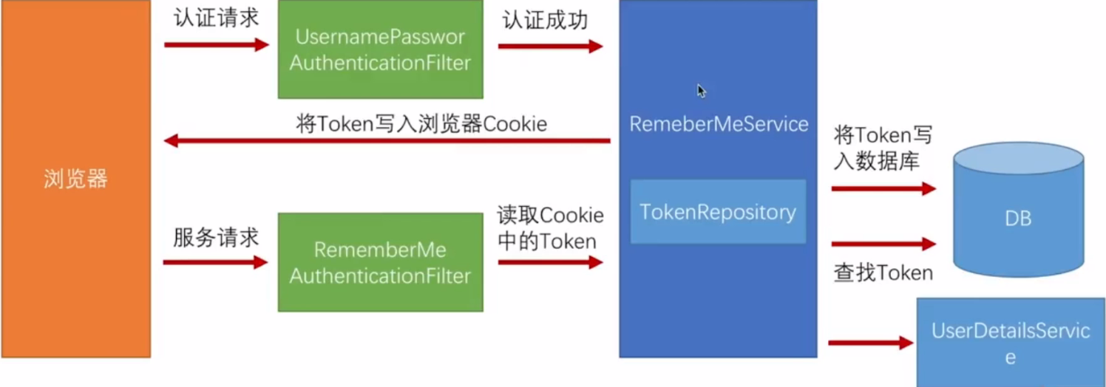

在页面加一个checkbox，name为remember-me

在browser中添加一个PersistentTokenRepository(SecurityConfig类中配置), JdbcTokenRepositoryImpl实在数据库中建立一个一张表，将token存放到数据库中,之后将JdbcTokenRepositoryImpl和userDetailsService以及过期时间(单位s)配置到Secyrity中

|  |
| --- |
| @Autowired private DataSource dataSource; @Autowired @Qualifier("myUserDetailsService") private UserDetailsService userDetailsService;  @Bean public PersistentTokenRepository persistentTokenRepository(){  JdbcTokenRepositoryImpl jdbcTokenRepository=new JdbcTokenRepositoryImpl();  jdbcTokenRepository.setDataSource(dataSource);  return jdbcTokenRepository; }  @Override protected void configure(HttpSecurity http) throws Exception {  http. ……………  //配置记住我 .and().rememberMe() .tokenRepository(persistentTokenRepository()) .tokenValiditySeconds(securityProperties.getBrowser().getRememberMeSeconds()) .userDetailsService(userDetailsService)  ……………………………………  } |

建表语句

|  |
| --- |
| create table persistent_logins (username varchar(64) not null, series varchar(64) primary key, token varchar(64) not null, last_used timestamp not null); |

在登录时勾选记住我后，会在本地写入一个Cookie（remember-me）将该cookie放到postman中可以免登录。在数据库中会多一条user的登录记录。

## 3.5短信验证逻辑

1.开发验证码接口 2.校验短信验证码接口并登录 3.重构

### 3.5.1发送短信验证码

core中定义一个发送的接口以及一个默认的实现

|  |
| --- |
| public interface SmsCodeSender {  void send(String mobile,String code);  }  @Slf4j  public class DefaultSmsCodeSender implements SmsCodeSender{  @Override  public void send(String mobile, String code) {  log.info("向手机"+mobile+"发送验证码:"+code);  }  } |

注入bean

|  |
| --- |
| @Configuration  public class ValidateCodeConfig {  /**  * 配置默认的发送短信实现  * ConditionalOnMissingBean 当系统中存在已有的name的bean时覆盖当前bean,用于重写或扩展  * @return  */  @Bean  @ConditionalOnMissingBean(name = "smsCodeSender")  public SmsCodeSender smsCodeSender(){  return new DefaultSmsCodeSender();  }  } |

验证码类

|  |
| --- |
| @Data  @NoArgsConstructor  @AllArgsConstructor  public class ValidateCode {  private String code;  private String mobile;  private LocalDateTime expireTime;  public boolean isExpried() {  return LocalDateTime.now().compareTo(expireTime) >= 0;  }  public boolean verify(String codeRequest,String mobileRequest) {  boolean flag=StringUtils.equals(mobile,mobileRequest);  if(flag){  flag=StringUtils.equals(code,codeRequest);  }  return flag;  }  public ValidateCode(String code,String mobile, int expire) {  this.code = code;  this.mobile = mobile;  this.expireTime = LocalDateTime.now().plusSeconds(expire);  }  } |

创建验证码方法

|  |
| --- |
| public ValidateCode generateSmsCode(String mobile){  SmsCodeProperties sms = securityProperties.getValidateCode().getSms();  String code = RandomStringUtils.randomNumeric(sms.getLength());  ValidateCode validateCode=new ValidateCode(code,mobile,sms.getExpireIn());  return validateCode; } |

Controller接受手机号并发送

|  |
| --- |
| @GetMapping("/code/sms") public String createSmsCode(HttpServletRequest request, HttpServletResponse response) throws ServletRequestBindingException {  String mobile = ServletRequestUtils.getRequiredStringParameter(request, "mobile");  ValidateCode smsCode = validateCodeGenerator.generateSmsCode(mobile);  sessionStrategy.setAttribute(new ServletWebRequest(request), AppConst.SMS_CODE, smsCode);  smsCodeSender.send(mobile,smsCode.getCode());  return smsCode.getCode(); } |

browser中配置过滤当前路径 不展示

### 3.5.2短信验证

短信认证流程

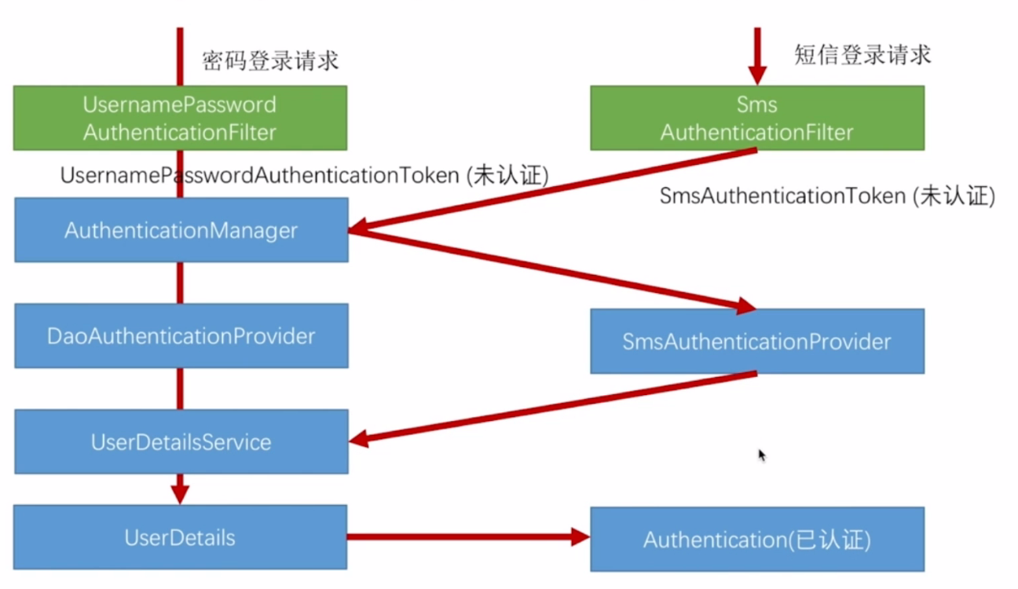

以上流程中没有验证短信验证码是否正确，如同图形验证码一样，在sms过滤器之前验证短信验证码。可以重用。

Core中创建，可以提供给browser和app使用

创建SmsCodeAuthenticationToken 可以参考UsernamePasswordAToken

不贴代码了

创建SmsCodeAuthenticationFilter 参考usernamepasswordAFilter

拷过来代码，原先存在username和password，现在只要mobile，修改Token。

创建SmsCodeAuthenticationProvider 实现接口AuthenticationProvider

|  |
| --- |
| @Data  public class SmsCodeAuthenticationProvider implements AuthenticationProvider {  private UserDetailsService userDetailsService;  /**  * 身份验证逻辑  *  * @param authentication  * @return  * @throws AuthenticationException  */  @Override  public Authentication authenticate(Authentication authentication) throws AuthenticationException {  SmsCodeAuthenticationToken authenticationToken= (SmsCodeAuthenticationToken) authentication;  String mobile = (String) authenticationToken.getPrincipal();  //将电话传入方法获取用户信息  UserDetails user=userDetailsService.loadUserByUsername("逢魔Zi-O");  if (user==null){  throw new InternalAuthenticationServiceException("无法获取用户信息");  }  SmsCodeAuthenticationToken resultAuthenticationToken=new SmsCodeAuthenticationToken(user,user.getAuthorities());  resultAuthenticationToken.setDetails(resultAuthenticationToken.getDetails());  return resultAuthenticationToken;  }  /**  * AuthenticationManager判断执行那个provider  * @param authentication  * @return  */  @Override  public boolean supports(Class<?> authentication) {  //判断传进来的是否是SmsCodeAuthenticationToken类型  //SmsCodeAuthenticationToken 继承 AbstractAuthenticationToken 实现 Authentication  return SmsCodeAuthenticationToken.class.isAssignableFrom(authentication);  }  } |

创建短信验证码逻辑 参考图形验证码 略过，需要手机号加验证码验证

配置短信验证码，在core中配置，方便browser和app使用

|  |
| --- |
| @Component  public class SmsCodeAuthenticationSecurityConfig extends SecurityConfigurerAdapter<DefaultSecurityFilterChain, HttpSecurity> {  @Autowired  @Qualifier(value = "swbSecurityAuthenticationSuccessHandler")  private AuthenticationSuccessHandler successHandler;  @Autowired  @Qualifier(value = "swbSecurityAuthenticationFailureHandler")  private AuthenticationFailureHandler failureHandler;  @Autowired  @Qualifier(value = "myUserDetailsService")  private UserDetailsService userDetailsService;  @Override  public void configure(HttpSecurity http) throws Exception {  //创建过滤器filter  SmsCodeAuthenticationFilter filter = new SmsCodeAuthenticationFilter();  //filter设置AuthenticationManager  filter.setAuthenticationManager(http.getSharedObject(AuthenticationManager.class));  //filter设置成功和失败的处理器 Autowired注入 在browser中写过，app中可以重写  filter.setAuthenticationSuccessHandler(successHandler);  filter.setAuthenticationFailureHandler(failureHandler);  //配置Provider  SmsCodeAuthenticationProvider provider = new SmsCodeAuthenticationProvider();  provider.setUserDetailsService(userDetailsService);  http.authenticationProvider(provider)  .addFilterAfter(filter, UsernamePasswordAuthenticationFilter.class);  }  } |

配置短信验证码的过滤器 在browser的BrowserSecurityConfig中

|  |
| --- |
| ……………………………  // configure方法中  SmsCodeFilter smsCodeFilter = new SmsCodeFilter(); smsCodeFilter.setAuthenticationFailureHandler(failureHandler); smsCodeFilter.setSecurityProperties(securityProperties); smsCodeFilter.afterPropertiesSet();  http.addFilterBefore(smsCodeFilter, UsernamePasswordAuthenticationFilter.class)  .addFilterBefore(validateCodeFilter, UsernamePasswordAuthenticationFilter.class)  .formLogin()  ………………………………… |

在BrowserSecurityConfig中应用core中的配置SmsCodeAuthenticationSecurityConfig

|  |
| --- |
| Autowired注入  ……………….  // configure方法最后添加配置  .and().csrf().disable() .apply(smsCodeAuthenticationSecurityConfig); |

验证短信和密码登录均可

重构

1.图形验证码和短信验证码存在重复代码，需要修改(包括类内逻辑和配置)

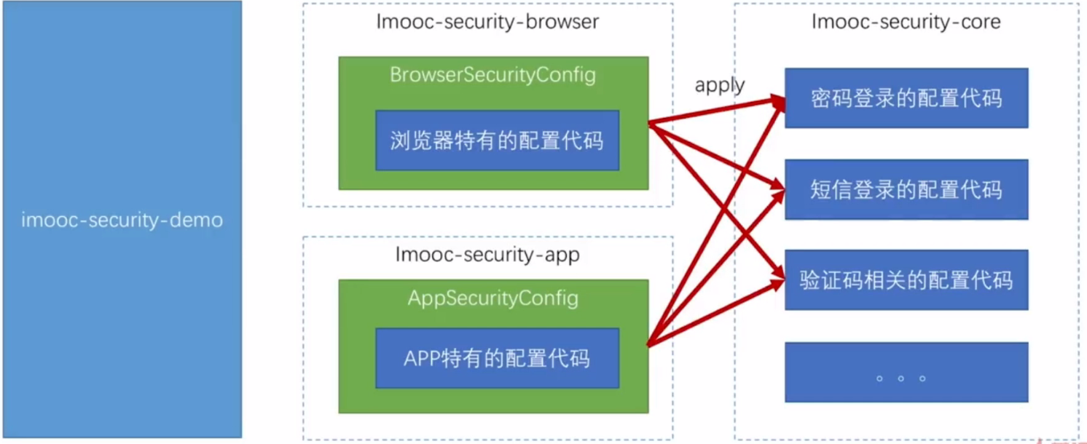

BrowserSecurityConfig配置。

图形验证码和短信验证码校验器合并 core中，可供browser和app使用

Rember-me仅供browser使用

提取部分公用方法以及变量

跳过

## 3.6总结

在服务中加了一条过滤器链，在过滤器链中添加了一些校验，可以自己配置新的校验

在通过校验后判断是否存在权限

# 4.第三方登陆

## 4.1 OAuth协议

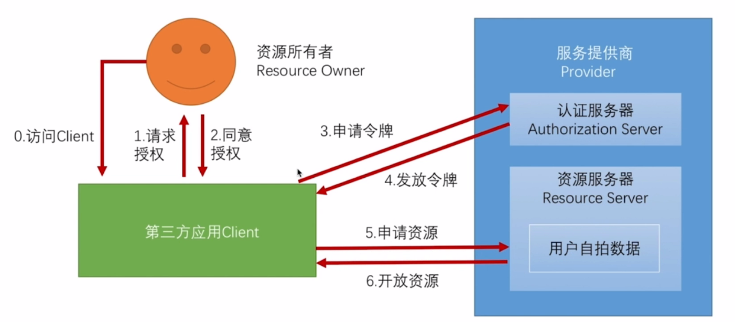

授权模式： 授权码，简化，密码，客户端。

授权码模式：

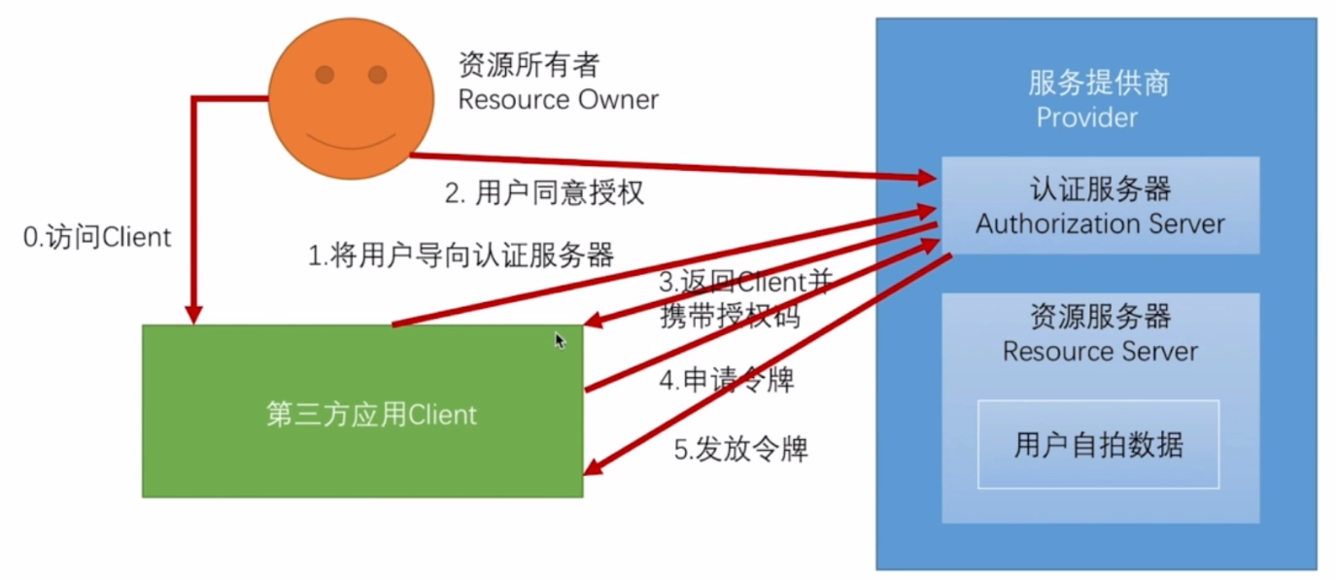

# 5.session管理

## 5.1单机session管理

Spring Boot2.2.5配置session过期时间

|  |
| --- |
| server.servlet.session.timeout=10S |

获取该值后，将转化为分钟单位，并与1比较，取最小值。也就是最少1分钟有效时间。

session过期后，访问接口提示，这与没有登陆访问接口的提示信息相同。不合理。

|  |
| --- |
| {"content":"访问信息需要身份认证"} |

在BrowserSecurityConfig配置HttpSecurity，指定session失效后的地址。并配置该路径不需要身份认证。

|  |
| --- |
| http.apply(smsCodeAuthenticationSecurityConfig)  ……………………  .and()  .sessionManagement()  .invalidSessionUrl(SecurityConstants.DEFAULT_SESSION_INVALID_URL)  .and()  // 开始请求权限配置  .authorizeRequests()  //当前路径不需要认证  .antMatchers(…………………..  SecurityConstants.DEFAULT_SESSION_INVALID_URL,  ……………………………… |
| 失效的url处理  @GetMapping("/session/invalid")  @ResponseStatus(HttpStatus.UNAUTHORIZED)  public SimpleResponse sessionInvalid(){  String message="session失效，用户已过期";  return new SimpleResponse(message);  } |

.invalidSessionUrl(URL)失效后的跳转路径(2者取一个)

.invalidSessionStrategy(InvalidSessionStrategy)失效后的处理

并发控制:

指定数量，并配置处理器，处理用户被踢掉后的逻辑。

|  |
| --- |
| .sessionManagement()  .invalidSessionUrl(SecurityConstants.DEFAULT_SESSION_INVALID_URL)  //最大数量  .maximumSessions(1)  .expiredSessionStrategy(new BrowserSecuritySessionExpiredStrategy())  .and()  .and()  //开始请求权限配置  .authorizeRequests() |

BrowserSecuritySessionExpiredStrategy处理失败逻辑

|  |
| --- |
| @Slf4j  public class BrowserSecuritySessionExpiredStrategy implements SessionInformationExpiredStrategy {  @Override  public void onExpiredSessionDetected(SessionInformationExpiredEvent event) throws IOException, ServletException {  log.info("开始处理同一个用户不同机器多次登录逻辑");  Object principal = event.getSessionInformation().getPrincipal();  log.info(JSONUtil.toJsonStr(principal));  log.info("逻辑处理结束");  HttpServletResponse response = event.getResponse();  response.setContentType("application/json;charset=utf-8");  response.getWriter().write(  JSONUtil.toJsonStr(new SimpleResponse("你的账号在别的地方登录，该设备已下线")));  }  } |

也可以指定超出最大登录数量则无法访问

|  |
| --- |
| .and()  .sessionManagement()  .invalidSessionUrl(SecurityConstants.DEFAULT_SESSION_INVALID_URL)  //最大数量  .maximumSessions(1)  //达到最大登录数时，不允许登录  .maxSessionsPreventsLogin(true)  .expiredSessionStrategy(new BrowserSecuritySessionExpiredStrategy())  .and().and() |

5-9 18:21